**Bluetooth Technology**

**What is Bluetooth?**

* Bluetooth is a **short-range wireless communication** technology that enables devices to exchange data over short distances (typically up to **100 meters**) without using cables.
* It is designed to replace the need for physical connections between devices, offering **convenience** and **flexibility**.
* Bluetooth technology is used in everyday devices like smartphones, wireless speakers, keyboards, and more.

**Architecture of Bluetooth**

**Piconet:**

* Piconet is a type of Bluetooth network that containsone primary node called the master node and seven active secondary nodes called slave nodes.
* we can say that there is a total of 8 active nodes which are present at a distance of 10 meters.
* The communication between the primary and secondary nodes can be one-to-one or one-to-many.
* Possible communication is only between the master and slave; Slave-slave communication is not possible.
* It also has 255 parked nodes, these are secondary nodes and cannot take participation in communication unless it gets converted to the active state.

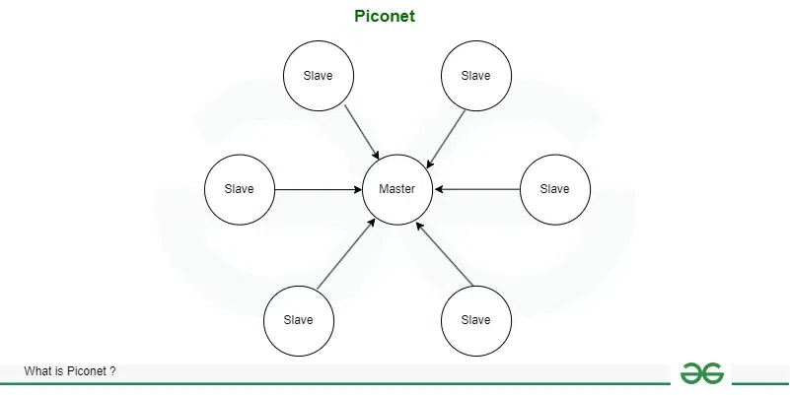

**Scatternet**

A **Scatternet** is created when **multiple Bluetooth piconets** are connected together.

* A device (called a **bridge node**) can be part of **two different piconets**:
  + It acts as a **slave** in one piconet and a **master** in another.
* This bridge node helps **forward messages** from one piconet to another.
* However, **a device cannot be a master in two piconets** at the same time.

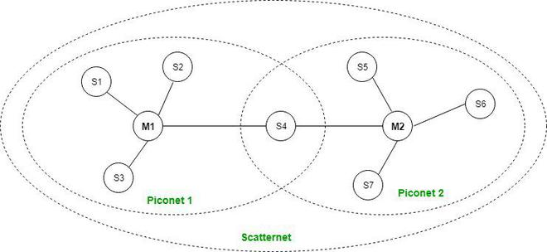

**Types of Bluetooth**

* **In-Car Headset:** One can make calls from the car speaker system without the use of mobile phones.
* **Stereo Headset:** To listen to music in car or in music players at home.
* **Webcam:** One can link the camera with the help of Bluetooth with their laptop or phone.
* **Bluetooth-Equipped Printer:** The printer can be used when connected via Bluetooth with mobile phone or laptop.

**Advantages of Bluetooth**

1. **Low Power Usage** – Ideal for battery-operated devices like wearables.
2. **No Cables** – Enables wireless communication between devices.
3. **Inexpensive** – Built into most smartphones and laptops.
4. **Secure** – Uses encryption and frequency hopping.
5. **Universal** – Works across different brands and platforms.

**Disadvantages**

* It can be hacked and hence, less secure.
* It has a slow data transfer rate of 3 Mbps.
* Bluetooth communication does not support [routing](https://www.geeksforgeeks.org/types-of-routing/).

**Applications of Bluetooth**

* It can be used in wireless headsets, wireless [PANs, and LANs.](https://www.geeksforgeeks.org/types-of-area-networks-lan-man-and-wan/)
* It can connect a digital camera wireless to a mobile phone.
* It can transfer data in terms of videos, songs, photographs, or files from one cell phone to another cell phone or computer.
* It is used in the sectors of Medical healthcare, sports and fitness, Military.

**Wi-Fi Technology**

**What is Wi-Fi?**

* WiFi is a wireless technology that allows electronic devices to connect to the internet and communicate with each other without a physical cable.
* This uses radio waves to transmit the data between a WiFi router and compatible devices like smartphones, computers, and smart home gadgets.
* These WiFi networks are common in homes, offices, and public spaces providing convenient internet access and local connectivity.
* This technology has become an essential part of modern digital life enabling wireless internet browsing, file sharing, and device communication in various settings.

**How does a Wi-Fi work?**

Wi-Fi is a wireless technology for networking, so it uses Electromagnetic waves to transmit networks.

**Main Internet Source (Base Station or Ethernet Connection):**

* This is the actual internet connection that comes from your broadband provider (like Jio, Airtel, etc.).

**Router or Access Point:**

* The router is the device that takes this internet and **converts it into wireless signals** using **radio waves**.
* It **spreads the signal** so nearby devices can connect to it.

**Devices (Mobile, Laptop, TV, etc.):**

* These devices **receive the radio signals** from the router.
* The device reads these signals in **binary form** (1s and 0s), which lets you browse the internet, watch videos, or send messages.

**How Binary Data Travels in Wi-Fi:**

* Wi-Fi sends data using **radio waves**.
* Devices understand data in **binary** (1 = wave peak, 0 = wave low).
* That’s how information is sent and received over Wi-Fi.

**Security in Wi-Fi:**

* **SSID (Service Set Identifier):**
  + This is the **name of your Wi-Fi network**. It helps you know which network you're connecting to (like “Praveen_Home_WiFi”).
* **WPA-PSK (Wi-Fi Protected Access - Pre-Shared Key):**
  + A **password system** that protects your Wi-Fi from unknown users.
  + There are **3 versions**: WPA, WPA2, and WPA3 (WPA3 is the most secure).

**Network Type:**

* Wi-Fi can also work in **Ad-Hoc Mode**, where two devices connect **directly to each other** without a router.

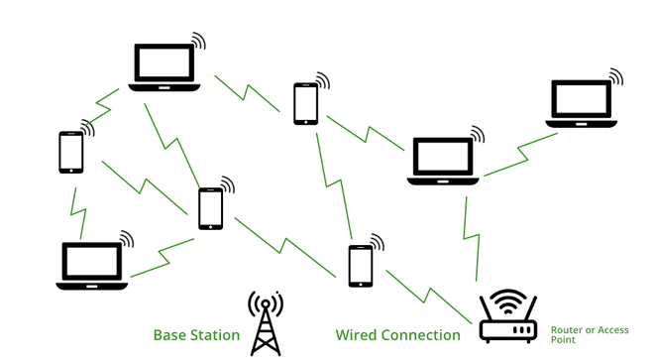**Advantages of WiFi**

1. **High-Speed Connectivity** – Great for streaming, downloading, and gaming.
2. **Multiple Device Access** – Many users can connect to a single router.
3. **Mobility** – Internet access without physical connections.
4. **Cost-Effective** – No need for wired connections in every room.
5. **Secure Access** – WPA2/WPA3 encryption keeps data protected.

**Disadvantages of Wi-Fi**

* If your Wi-Fi is not protected with a strong password, **hackers can break in** and steal your data.
* Wi-Fi signals can get **blocked by walls** or other objects. As a result, **speed becomes slow.**
* Wi-Fi routers need **electricity** to run. • If there’s a **power cut**, the Wi-Fi stops working, and you can’t use the internet.

**Applications of WiFi**

1. **Home Internet** – Smart homes, streaming, and browsing.
2. **Offices and Schools** – Shared network and cloud access.
3. **Public WiFi Zones** – Airports, cafes, malls, and libraries.
4. **IoT Devices** – Smart TVs, CCTV, home automation systems.
5. **Online Learning** – Supports platforms like Zoom, Google Meet, etc.

**Types of Wi-Fi:**

1. **Wi-Fi 1 (1999)**  
   Slow but works over long distance. Speed: 2–11 Mbps. Uses 2.4 GHz band.
2. **Wi-Fi 2 (1999)**  
   Faster (up to 54 Mbps) but shorter range. Uses 5 GHz band.
3. **Wi-Fi 3 (2003)**  
   Mix of Wi-Fi 1 and 2. Good speed (54–108 Mbps) and good range. Uses 2.4 GHz.
4. **Wi-Fi 4 (2009)**  
   Big upgrade! Supports both 2.4 GHz and 5 GHz. Speed: 72–600 Mbps. More stable connection.
5. **Wi-Fi 5 (2014)**  
   Very fast! Great for HD streaming and gaming. Speed: up to 1733 Mbps. Uses 5 GHz.
6. **Wi-Fi 6 (2019)**  
   Super fast! Works well even with many devices. Speed: up to 9.6 Gbps. Uses both 2.4 GHz and 5 GHz.

**Quick Tip to Remember**

* **Smaller number = Older and slower Wi-Fi**
* **Bigger number = Newer and faster Wi-Fi**